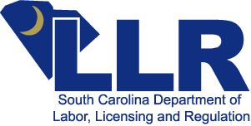


South Carolina Department of Labor, Licensing and Regulation

BOILER SAFETY PROGRAM
110 Centerview Drive, Columbia, S.C. 29210
P.O. Box 11329, Columbia, S.C. 29211-1329
Telephone 803-896-5171 Fax 803-896-4814
www.llr.state.sc.us

Report of Unregistered Boiler

Document 240

Reporter’s Name: Date Viewed Boiler:

Telephone Number:

User’s Name: Contact Person:

Contact Person’s Telephone Number:

User’s Physical Address: City: State: ZIP Code: County:

Comments:

Date received by the department: __________________ Reviewed by: _____________________________

Outline directions to site of property involving dispute. Directions should be to a specific reference point in your area to allow the field inspector to proceed directly to the location. Attach a map or on the back of this page, draw a sketch using highway and road numbers, names and other landmarks.

________________________________________ ____________________
Reporter’s Signature Date

Return completed form to:

S.C. LLR, Boiler Safety Program
Post Office Box 11329
Columbia, South Carolina 29211-1329
Telephone: (803) 896-5171
Fax: (803) 896-4814

