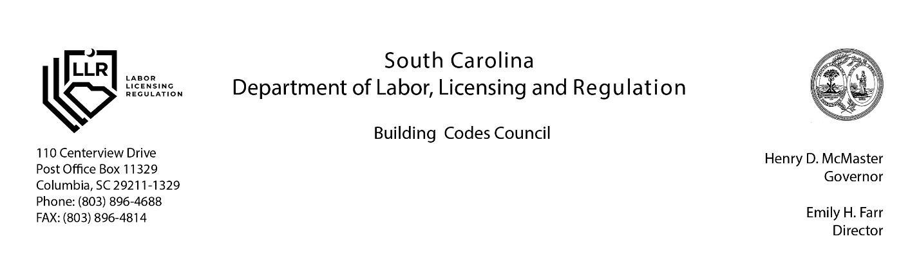

SUPPLEMENTARY PLAN REVISION APPLICATION
By completing and submitting this form, the Manufacturer is attesting to the accuracy of the information.

Manufacturer: __________________________________________________________________________
Address: _______________________________________________________________________________
Phone No.: _____________________________________________________________________________
Third Party Inspection Agency Address: ______________________________________________________
Third Party Inspection Agency Phone No.: ____________________________________________________
Original SC Approval No.: ________________________ Date of Approval: _______________________
Model Name/Number: ____________________________

Building/Component Plans Electrical Plans
Mechanical Plans Specifications
Test Data Quality Control Manual
Calculations (Type) Plumbing Plans Other (Specify)

Description of Change: _________________________________________________________________________
_____________________________________________________________________________________________
This is to certify that the Documents submitted conform to the South Carolina Modular Buildings Construction Act.

Architect/Engineer Name: _____________________________________ Title: _______________________
Agency Name: ________________________________________________________________________________

Manufacturing Facility Representative Name: ___________________________ Title: _______________________

Personal information provided in this application may be subject to public scrutiny or release under the S.C. Freedom of Information Act or other provisions of federal and state law.

Date check mailed: ____________________

Supplementary Plan Revision Application (2/2020) Page 1 of 1

